
DEBRETABOR UNIVERSITY
GAFAT INSTITUTE OF TECHNOLOGY
DEPARTMENT OF ELECTRICAL AND COMPUTER ENGINEERING
COMPUTER STREAM INTERNSHIP DOCUMENTATION
Host Company:Amhara Innovation and Technology bureau(AITB)
Project on : Web Based Human Resource Management System for AITB
Group Members
Name ID
1. Gizachew Adamu DTU14R0860
2. Workineh Bizualem DTU14R1257
3. Henok Arega DTU14R0864
4. Admasu Dessie DTU14R1075

Advisor: Mr.Mulualem.

August, 2025
BAHIR DAR, ETHIOPIA

Declaration

We, Gizachew Adamu, Workineh Bizualem, Henok Arega and Admasu Dessie, a 5th-year Computer Engineering student, have undertaken our internship experience at Bahir Dar under the Amhara Innovation and Technology Bureau for a period of three months (December 6, 2018 E.C March 4, 2018 E.C). This work was carried out under the guidance of Mr.Mekuant . and Mr. Mulualem.

We hereby certify that this report, entitled “Design and Development of a Web-Based human resource Management System for AITB”, is our original work and has been compiled according to the internship report writing guidelines provided by the Institute

Gizachew Adamu ___________________ _____________
Workineh Bizualem ___________________ _____________
Admasu Dessie ___________________ _____________
Henok Arega ___________________ _____________

Name of the student Signature Date

Mr. Mekuannt ___________________ _____________
Name of the Academic Advisor Signature Date

Abstract
The Amhara Innovation and Technology Bureau (AITB) is a leading governmental institution dedicated to driving digital transformation and technological advancement within the Amhara region. To modernize its internal operations, this project focused on developing a secure, web-based Human Resource Management System (HRMS) to replace the bureau's inefficient, paper-based manual processes, which were prone to data redundancy and security risks.
The system was designed using Unified Modeling Language (UML) and implemented using the MERN stack (MongoDB, Express.js, React, and Node.js) within a three-tier architecture. Key functionalities include Role-Based Access Control (RBAC), secure JWT authentication, and an Employee Self-Service (ESS) portal for leave management and profile updates. By centralizing personnel records and automating administrative workflows, the HRMS significantly enhances data integrity, reduces processing time, and minimizes human energy loss. Ultimately, the system provides AITB with a scalable digital framework that aligns with its mission of fostering technological progress and efficient service delivery.

Acknowledgment

We would like to express our deepest gratitude Debre Tabor Gafat institute of technology (GIT) and the Amhara Innovation and Technology Bureau for providing us with the opportunity to undertake our internship and gain valuable practical experience.

Our sincere thanks go to our academic advisor, Mr.Mekuant, for his continuous guidance, encouragement, and constructive feedback throughout the development of this project. We are also thankful to our company advisor, Mr. Mulualem, his support and insights during our time at the Amhara Innovation and Technology Bureau.

Finally, we would like to extend our appreciation to our family, friends, and colleagues for their encouragement and support, which contributed significantly to the successful completion of our internship and this report.

List of Acronyms and Abbreviations
HRMS………………………………Human resource management system
AITB………………………………..Amhara innovation and technology bureau
SMS………………………………….Short Message Service
SSGI…………………………………Space Science and Geospatial Institute
ILO…………………………………..International Labour Organization
API…………………………………Application Programming Interface
IT………………………………….…Information Technology
ANRS……………………………..…Amhara National and Regional State
MINT…………………………………Ministry of Innovation and Technology
UI………………………………….…User Interface
CRUD…………………………………Create Read Update Delete
HTTP…………………………………HyperText Transfer Protocol.
NoSQL………………………………..Non-Structured Query Language

Table of Contents
Declaration 2
Abstract 3
Acknowledgment 4
List of Acronyms and Abbreviations 5
List of Tables iv
List of Figures v
CHAPTER ONE 1
1.1 Background of the Company 1
1.2 Mission and Objectives 1
1.3 Main Products or Services of the Company 2
1.4 Main Customers or End-users 2
1.5 Organizational Structure of the Company 4
1.6 Its Work Flow in Each Departments 4
CHAPTER TWO 7
2.1 Internship experience 7
2.2 The section we have been working in 8
2.3 The work task we have executed 8
2.4 Methods, Tools and Techniques we have used 9
2.5 challenges and problems we have been facing 10
2.6 Overall benefits we get from the internship 11
2.6.1 What we gained in terms of improving my practical skills 11
2.6.2 Interpersonal communication skills 12
2.6.3 Improving Leadership Skill 13
2.6.4 About work ethics related issues 14
2.6.5 Improving entrepreneurship skills 15
CHAPTER THREE 17
3 INTRODUCTION 17
3.1 Background of the project 17
3.2 Problem Identification 17
3.3. Objectives 18
3.3.1 General objectives 18
3.3.2 Specific objectives 18
3.4. Methodology 18
3.4.1. Data collection 18
3.4.2. System Analysis and Design 19
3.4.3 Tool selection 19
3.5. Feasibility Study 20
3.5.1 Technical feasibility 20
3.5.2. Operational feasibility 20
3.5.3. Economic feasibility 21
3.5.4. Legal feasibility: 21
3.5.5. Schedule feasibility 21
3.5.6 Cost Estimation 22
3.6. Scope of the project 23
3.7. Significance of the project 23
3.8. Team Organization Management and Composition 24
CHAPTER -FOUR 25
4. REQUIREMENT ANALYSIS 25
4.1. Introduction 25
4.2 Existing system` 25
4.2.1 Description of the existing system 25
4.2.2 The drawbacks of existing system 26
4.2.3 Control and Security problem 27
4.2.4 Efficiency related problem: 27
4.2.5 Supplementary specification 27
4.3 Requirements of the Proposed System 28
4.3.1 Functional requirements 28
4.3.2 Non-functional requirements 30
CHAPTER FIVE 31
5. SYSTEM DESIGN 31
5.1 Purpose and Goals of Design 31
5.2 System use case 32
5.2.1 System use case description 33
5.2.2 Sequence Diagram 53
5.2.3 Activity diagram 66
5.2.4 Conceptual modeling: Class diagram 76
5.2.5 User Interface Prototyping 78
CHAPTER SIX 79
6. System design 79
6.1 Introduction 79
6.2 Class type architecture 79
6.3 Class modeling 81
6.4 State chart modeling 81
6.5 Collaboration modeling 83
6.6 Component modeling 84
Chapter SEVEN 85
7. Implementation and Testing 85
7.1 Introduction 85
7.2 implementation 85
7.2.1 System implementation 85
7.3. System User Interface (Screenshots & Descriptions) 88
7.3.1 AITB Public Portal: The Institutional Home Page 88
7.3.2. User Authentication and Gateway 89
7.3.3. HR Officer: Centralized Personnel Dashboard 89
7.3.4. Department Head: Workflow Approval Interface 90
7.3.5. Employee Self-Service (ESS) Portal 91
7.3.6. Public Recruitment (Applicant) Portal 92
7.4 Test Procedures 93
Chapter EIGHT 94
8. Conclusions and Recommendation 94
8.1Conclusion 94
8.2 Recommendations 94
Reference 95

List of Tables
Table 1 : schedule Feasibility 21
Table 2 : cost estimation 23
Table 3 : Team composition 24
Table 5 : Login System use case description 34
Table 6 : Create user account, delete user account and update user account 35
Table 7 : Manage Account System use case description 38
Table 8 : Employee Request System use case description 40
Table 9 : Approve Request System use case description 42
Table 10 : Vacancy Announcement System use case description 43
Table 11 : Applicant registration System Use Case description 44
Table 12 : Applicant Evaluation System Use Case description 46
Table 13 : Screen Applicant System Use Case description 47
Table 14 : Placement system use case description 49
Table 15 : Promotion Request system use case description 50
Table 16 : Promotion Approval system use case description 52
Table 17 : Send Payment order system use case description 53
Table 18 : Class type architecture 80

List of Figures
Figure 1 : Employee registration form 13
Figure 3 : System use case 18
Figure 4 : Login sequence diagram 39
Figure 5 : Sequence for Create account 40
Figure 6 : Sequence diagram to Update account 41
Figure 7 : sequence diagram for Delete user account 42
Figure 8 : Sequence diagram for employment requesting 43
Figure 9 : Sequence diagram for Promotion Request 44
Figure 10 : Sequence diagram for approve request 45
Figure 11 : sequence diagram for Vacancy Announcement 46
Figure 12 : Sequence diagram for Applicant Registration 47
Figure 13 : sequence diagram for Applicant evaluation 48
Figure 14 : screen applicant sequence diagram 49
Figure 15 : sequence for send payment order 50
Figure 16 : sequence for employee salary payment 51
Figure 17 : Activity diagram for Login 52
Figure 18 : Activity diagram for Vacancy announcement 53
Figure 19 : Activity diagram for Employee Request 54
Figure 20 : Activity diagram for Approve Request 55
Figure 21 : Activity diagram for Applicant Registration 56
Figure 22 : Activity diagram for Screen Applicant 57
Figure 23 : Activity diagram for Employee Placement 58
Figure 24 : Activity diagram for Send Payment Order 59
Figure 25 : Activity diagram for salary payment 60
Figure 26 : Activity diagram for Promotion Request 61
Figure 27 : Conceptual modeling Diagram 62
Figure 28 : User Interface flow diagram 64
Figure 29 : class type architecture 67
Figure 30 : class modeling 67
Figure 31 : state chart diagrams for new employee register 68
Figure 32 : State chart diagram for Login 69
Figure 33 : collaboration model for login 69
Figure 34 : collaboration model for employee register 70
Figure 35 : component modeling diagram 70

CHAPTER ONE

1.1 Background of the Company
The ANRS Innovations and Technology Bureau was established under Proclamation No. 1263/2021 on January 25, 2022, as an autonomous federal body tasked with nurturing talent and
Promoting technological progress in the Amhara region. Its creation marked a significant step in
Ethiopia’s national reform efforts to prioritize science, technology, and innovation. Before these Reforms, the region faced challenges in fostering technological growth, but the bureau’s establishment shifted the focus toward innovation and digital skills development. [6]
The bureau’s formation aligns with Ethiopia’s ambition to lead in African technological advancement. It builds on the foundation laid by the Ethiopian Ministry of Innovation and Technology (MInT), restructured in 2019 to unify efforts in science, technology, and communication. The bureau has since launched impactful initiatives, such as the "Unlock the Inner Locked Potential" training program across nine universities in the Amhara region. It has also collaborated with partners like the Space Science and Geospatial Institute (SSGI) and the International Labour Organization (ILO) to advance its mission. Notable efforts include training professionals in Bahir Dar on the National Business Agility Portal and supporting Ethiopia’s space science initiatives, such as the launch of two satellites in recent years. [6]

1.2 Mission and Objectives
The Bureau's core mission is to cultivate a generation proficient in digital literacy, technological innovation, and entrepreneurship. This aligns with the broader vision outlined in the Amhara Region's 25-year development plan, which emphasizes the integration of digital technologies to achieve socio-economic progress. A significant program under this initiative is the "Digital
Amhara Initiative," launched in 2025, aiming to equip over five million youth with essential digital skills over the next five years.
Key Programs and Initiatives
- Digital Amhara Initiative: This flagship program focuses on enhancing digital literacy among the youth, preparing them for the demands of the digital economy.
- Ethiopian Code Initiative: An online platform designed to teach coding and software development skills, fostering a new generation of tech-savvy individuals
- Capacity Building and Training: The Bureau organizes workshops and training sessions aimed at improving digital competencies among students, educators, and professionals.

1.3 Main Products or Services of the Company
The ANRS Innovations and Technology Bureau offers a range of services to promote innovation, technological adoption, and capacity building. Its key services include:
- Talent Development Programs: The bureau runs initiatives like the "Unlock the Inner
Locked Potential" program, targeting university students and professionals to enhance digital and entrepreneurial skills. These programs aim to empower the region’s large youth population, aligning with Ethiopia’s focus on youth-driven technological progress.
- Technology and Innovation Training: The bureau conducts targeted training sessions, such as the National Business Agility Portal training for 30 professionals from six Bahir Dar city administration divisions and the building authority office. These sessions improve digital literacy and operational efficiency in public administration.
- Support for Digital Infrastructure: In collaboration with MInT, the bureau supports projects that strengthen digital infrastructure, contributing to Ethiopia’s "Digital Ethiopia 2025" strategy to address sectoral challenges and promote digital transformation.
- Research and Innovation Support: Through partnerships with institutions like the SSGI, the bureau facilitates research in space science and geospatial technologies, supporting
Ethiopia’s advancements in satellite technology and data-driven decision-making.
- Entrepreneurship and Startup Incubation: The bureau provides mentorship, resources, and access to innovation hubs, such as the planned ILO Digital Innovation Hub in the Somali Region, to support entrepreneurial ventures.
These services bridge the gap between theoretical knowledge and practical application, fostering a culture of innovation and technological self-reliance in the Amhara region.

1.4 Main Customers or End-users
The Amhara Innovation and Technology Bureau serves a diverse range of customers and end- users, reflecting its mission to advance technology, innovation, and digital literacy across the region. The main groups include:
1. Youth and Students
- The Bureau targets young people, including high school and university students, through initiatives like the Digital Amhara Initiative.
- These programs provide training in digital skills, coding, and entrepreneurship to prepare youth for participation in the digital economy.
2. Educational Institutions
- Schools, colleges, and universities benefit from training programs, workshops, and digital resources provided by the Bureau.
- The Bureau collaborates with these institutions to integrate technology and innovation into their curricula and research activities.
3. Startups and Entrepreneurs
- The Bureau supports local startups and innovators by offering mentorship, access to resources, and funding opportunities.
- Entrepreneurs are guided in technology adoption, product development, and scaling their businesses.
4. Government Agencies
- Other regional government bodies and public institutions collaborate with the Bureau to implement digital transformation initiatives.
- These partnerships help improve public service delivery, e-governance, and digital infrastructure.
5. Private Sector Companies
- Local businesses and tech companies are engaged for R&D, training, and innovation projects.
- The Bureau helps them adopt new technologies, build capacity, and drive regional economic growth.
6. General Public and Community Members
- Citizens benefit from digital literacy campaigns, awareness programs, and access to technological services.
- Community engagement ensures inclusivity and equitable access to digital tools.
The Bureau’s end-users range from youth, students, and entrepreneurs to educational institutions, government agencies, and the wider community. Its programs are designed to reach all segments of society, fostering technological adoption and innovation across the Amhara Region.

1.5 Organizational Structure of the Company
The ANRS Innovations and Technology Bureau operates under a structured hierarchy to manage its diverse functions effectively. While specific details of the organizational chart are not publicly available, a typical structure for such a regional bureau includes:
- Bureau Head/Director General: Oversees all operations, sets strategic goals, and represents the bureau in regional and national forums. The director ensures alignment with MInT’s objectives and national policies.
- Deputy Directors: Manage specific portfolios, such as innovation programs, technology training, and partnerships, coordinating with department heads to implement initiatives.
- Departments:
- Innovation and Research Department: Focuses on research support, collaboration with academic institutions, and development of innovation hubs.
- Training and Capacity Building Department: Manages training programs like the
- National Business Agility Portal and "Unlock the Inner Locked Potential" initiatives.
- Technology Implementation Department: Oversees the deployment of digital infrastructure and projects like ሀበሻ Treasure.
- Partnerships and External Relations Department: Handles collaborations with national and international partners, such as MInT, SSGI, and the ILO.
- Administrative and Finance Department: Manages budgeting, human resources, and operational logistics.
- Regional Coordinators: Facilitate program implementation across zones like Bahir Dar and Meket, ensuring localized impact.
This structure ensures efficient coordination and flexibility to address regional needs.

1.6 Its Work Flow in Each Departments
The workflow within the ANRS Innovations and Technology Bureau is tailored to each department’s objectives, ensuring effective execution of its mandate. Below is an overview of the workflows in key departments:
1. Innovation and Research Department:
- Identification: Identifies research priorities, such as space science or digital health, through consultations with partners like SSGI.
- Collaboration: Establishes partnerships with universities and research institutes to fund and support projects.
- Implementation: Oversees research projects, monitors progress, and disseminates findings to inform policy and practice.
2. Training and Capacity Building Department:
- Planning: Designs training programs based on regional needs, such as digital literacy for government officials or entrepreneurial skills for youth.
- Execution: Conducts training sessions, such as the National Business Agility Portal training in Bahir Dar, involving up to 30 participants per session.
- Evaluation: Assesses training outcomes through feedback and performance metrics to ensure effectiveness.
3. Technology Implementation Department:
- Project Initiation: Identifies technology projects to address regional needs like e- commerce accessibility.
- Development: Collaborates with developers and interns to build and test solutions, integrating systems like Chapa and Telebirr for payments.
- Deployment and Maintenance: Rolls out projects and provides ongoing support, addressing challenges like API integration issues.
4. Partnerships and External Relations Department:
- Engagement: Initiates partnerships with organizations like the ILO or MInT to secure funding and technical expertise.
- Coordination: Manages joint projects, such as the ILO Digital Innovation Hub, ensuring alignment with regional goals.
- Reporting: Communicates progress to stakeholders and incorporates feedback into future initiatives.
5. Administrative and Finance Department:
- Budgeting: Allocates funds for training, research, and technology projects, ensuring fiscal responsibility.
- Human Resources: Recruits and manages staff, including interns working on projects like ሀበሻ Treasure!
- Logistics: Supports operational needs, such as facilities for training sessions in Bahir Dar.
Conclusion
The ANRS Innovations and Technology Bureau is a cornerstone of technological and innovative progress in the Amhara region. Since its establishment in 2022, it has driven impactful initiatives, from talent development to digital infrastructure projects like ሀበሻ Treasure. By serving diverse stakeholders, maintaining a robust organizational structure, and implementing efficient workflows, the bureau is well-positioned to contribute to Ethiopia’s vision of becoming a technologically advanced nation.

CHAPTER TWO

2.1 Internship experience
During our three-month internship at Bahir Dar under the Amhara Innovation and Technology Bureau, We worked on the design and development of web based human resource management system. The purpose of this internship was to gain practical exposure and modern software development practices.
Our main responsibilities included:
- Requirement Gathering and Analysis: Worked closely with our supervisor, Mr.Mulualem, and Innovation and Technology staff to collect user needs and translate them into functional specifications. This phase helped us to understand the importance of clear communication and thorough analysis before development.
- System Design: Participated in designing both the user interface and the database schema.
For the UI, We planned a navbar and sidebar layout to ensure intuitive navigation. For the backend, we designed relationships between users, roles, incidents, and service requests.
- Frontend Development: Used React to build responsive pages for Incident Management,
Service Requests, and the Admin Dashboard. Implemented features such as dynamic forms, interactive tables, and charts for statistics (e.g., open incidents, SLA compliance, and resolution times).
- Backend Development: Created a Node.js REST API and connected it to a MongoDB database. Implemented service and controller logic for assigning, closing, approving, and rejecting service requests.
- Notification Integration: email notification services to ensure users received real-time updates on the status of incidents and service requests.
- Testing: Performed unit and integration testing to ensure application reliability and usability.
- Collaboration and Documentation: Used GitHub for version control and participated in code reviews with team members. Documented the project’s features and workflows to assist future developers and stakeholders.
In general, an internships thought of as a program which “bridges the gap” between the academic environment and a future work environment. Many employers prefer students who have previous work experience and the internship provides that. Students that participate in an internship are generally more confident and more qualified when seeking future employment

2.2 The section we have been working in
During our internship at Bahir Dar under the Amhara Innovation and Technology Bureau, we were primarily assigned to the IT Service Management development initiative but worked independently rather than as part of a dedicated team. Instead of being placed within a formal section with multiple staff members, we operated as a self-directed intern developer under the general guidance of our supervisor, Mr. mulualem.
In this setup, we were responsible for planning, designing, and implementing the HRMS web application for IT Service Management on our own. While we occasionally sought feedback or approval from my supervisor, we managed the project’s daily activities such as requirement analysis, frontend and backend development, and testing without regular collaboration from other developers.
This independent assignment allowed me to:
- Gain a clear understanding of the full development lifecycle, from requirement gathering to deployment.
- Strengthen my ability to work autonomously, solve problems, and make design decisions.
- Experience the challenges and rewards of self-managed project work, including balancing time, priorities, and quality without direct peer collaboration.
Although we worked the experience provided valuable exposure to how individual contributions can still support broader organizational goals within the Amhara Innovation and
Technology Bureau’s mission to enhance IT service delivery

2.3 The work task we have executed
Throughout my internship, we were fully responsible for designing and developing an HRMS web application for AITB. Since we worked independently, we executed all major phases of the project myself. The key tasks we completed include:
1. Requirement Gathering and Analysis
- Met with our supervisor, Mr. mulualem, to understand the needs of the Amhara
Innovation and Technology Bureau.
- Identified essential HRMS processes to include, such as incident management, service request handling, and administrative controls.
- Defined the workflow for submitting, tracking, and closing service requests.
2. System Design and Planning
- Designed the user interface layout with a navbar and sidebar for easy navigation.
- Created the database schema with tables for users, roles, incidents, and service requests, establishing relationships to ensure data consistency.
- Planned the API endpoints for managing incidents, service requests, and user authentication.
3. Frontend Development
- Built a React-based interface for incident management, service request tracking, and dashboard visualization.
- Implemented dynamic forms, interactive tables, and charts to display statistics such as SLA compliance, average resolution time, and open incidents.
- Applied responsive design principles for usability on multiple devices.
4. Notification Integration
- Integrated email notification systems to keep users updated on the status of their requests and incidents.
5. Testing and Debugging
- Performed unit and integration testing to verify the functionality of the frontend and backend.
- Fixed bugs related to form validation, database queries, and deployment environment variables.
5. Documentation
- Documented the system features, setup instructions, and workflows to support future maintenance or improvements.

2.4 Methods, Tools and Techniques we have used
During the development of the HRMS web application for AITB, we applied a combination of methods, tools, and techniques to ensure the project was completed effectively and met professional standards.
Methods:

- Agile-Inspired Workflow: Though working alone, we followed an iterative approach breaking the project into small tasks, setting weekly goals, and reviewing progress with our supervisor.
- Requirement-Driven Design: Started with requirement analysis sessions to understand the user needs and designed both the frontend and backend accordingly.
- Testing and Feedback Cycles: Conducted regular testing after implementing each module and sought feedback to make incremental improvements.
Tools:
- Frontend Development: React.js – for building a responsive and dynamic user interface.
- Backend Development: Node.js & Express.js – for creating a RESTful API and managing server-side operations.
- MongoDB – as the database for storing incidents, service requests, and user data.
- Notification Services: Nodemailer – for sending email updates.
- Version Control and Deployment: Git & GitHub – for version control and tracking project changes.
- Design and Documentation: Word Processor – for writing documentation and reports.
Techniques:
- Responsive Web Design: Ensured the application was usable on different devices and screen sizes.
- RESTful API Design: Structured endpoints for reliable communication between frontend and backend.
- CRUD Operations: Implemented Create, Read, Update, and Delete operations for managing incidents and requests.
- Error Handling and Debugging: Used console logging, debugging tools, and test cases to identify and fix issues quickly.
- Role-Based Access Control: Applied user roles (e.g., admin, requester) to secure sensitive actions.

2.5 challenges and problems we have been facing
During the course of our internship and the development of the HRMS web application, we encountered several challenges and problems that tested our technical and problem-solving skills:
1. Limited Resources and Documentation
- Challenge: Some tools lacked localized or beginner-friendly documentation.
- Impact: Progress slowed while we searched for reliable solutions or examples online.
- Solution: we relied on official documentation, online forums, and small test projects to experiment with features before integrating them into the main application.
2. Debugging and Error Handling
- Challenge: Bugs in the frontend (React components) and backend (API endpoints) were sometimes difficult to trace, especially when dealing with asynchronous operations or state management.
- Impact: Time-consuming troubleshooting was required.
- Solution: we used browser developer tools, console logging, and incremental testing to isolate and fix issues.
3. Time Management
- Challenge: Balancing requirement analysis, coding, testing, and documentation within the internship’s limited time frame was demanding.
- Impact: Some features required prioritization to meet deadlines.
- Solution: we applied an iterative workflow, focusing first on core functionalities before adding extra features or optimizations.

2.6 Overall benefits we get from the internship
The internship at Bahir Dar under the Amhara Innovation and Technology Bureau provided significant personal, academic, and professional benefits. Working independently on the web based HRMS for AITB allowed me to gain practical experience that complemented my theoretical knowledge.

2.6.1 What we gained in terms of improving my practical skills
The internship provided an excellent platform to enhance our practical skills by allowing me to apply theoretical knowledge to a real-world project. Working independently on the web based human resource management system helped me strengthen both our technical and professional abilities. The key areas of improvement include:
1. Software Development Skills
- Frontend Development: Improved proficiency in React.js, creating interactive and responsive user interfaces, handling forms, state management, and dynamic data visualization.
- Backend Development: Gained practical experience with Node.js and Express.js, building RESTful APIs to handle CRUD operations for incidents and service requests.
- Database Management: Enhanced my ability to design, implement, and query a
MongoDB database, ensuring data integrity and effective relationships between entities.
2. Integration of External Services
- Learned to integrate email notifications for real-time communication with users.
- Gained hands-on experience handling API documentation, authentication, and service configuration in practical settings.
3. Problem-Solving and Debugging
- Developed critical thinking and troubleshooting skills while identifying and resolving frontend, backend, and deployment issues.
- Learned how to use debugging tools, log analysis, and incremental testing to isolate and fix errors efficiently.
4. System Design and Project Implementation
- Practiced planning the full software development lifecycle from requirement gathering to deployment.
- Improved my ability to design database schemas, structure APIs, and implement workflow logic aligned with HRMS best practices.
6. Time and Task Management
- Gained practical experience in organizing and prioritizing tasks, especially while working independently.
- Learned to set milestones, monitor progress, and adjust workflows to meet deadlines efficiently.

2.6.2 Interpersonal communication skills
Although we worked independently for most of our internship, the experience still provided valuable opportunities to develop interpersonal communication skills, which are essential for professional growth.
1. Communication with Supervisor
- Regularly interacted with our supervisor, Mr. mulualem, to report progress, seek feedback, and clarify requirements.
- Learned to present technical ideas clearly, explaining the functionality of the web application, proposed features, and challenges encountered.
- Developed the ability to receive constructive feedback and implement it effectively in our work.
Professional Correspondence
- Gained experience in writing emails and documentation that were clear, concise, and professional.
- Prepared technical reports, system documentation, and progress updates that could be easily understood by non-technical stakeholders. .

2.6.3 Improving Leadership Skill
Although we worked independently during my internship, the experience provided significant opportunities to develop leadership skills, which are essential for professional growth and career development.
1. Self-Leadership and Initiative
- Managed all aspects of the project, from requirement analysis to deployment, demonstrating the ability to take initiative and make decisions independently.
- Developed skills in planning, prioritizing, and executing tasks, which are fundamental aspects of effective leadership.
2. Decision-Making Skills
- Made critical decisions regarding system design, technology stack selection, workflow implementation, and notification integration.
- Learned to weigh different options, consider potential outcomes, and choose the most effective solution for each task.
3. Responsibility and Accountability
- Took full responsibility for the success and quality of the project, fostering a sense of ownership and accountability.
- Learned how to monitor progress, adjust strategies, and ensure that deadlines were met without direct supervision.
4. Strategic Thinking
- Applied leadership in planning the development process strategically, including iterative testing, prioritizing core features, and preparing documentation for future use.
- Developed the ability to anticipate challenges and plan solutions proactively, a key leadership trait.
5. Mentoring and Knowledge Sharing (Indirect)
- While we did not directly supervise others, documenting the system, workflows, and technical processes created a resource that could guide future interns or team members, demonstrating leadership through knowledge sharing.

2.6.4 About work ethics related issues
During my internship at Bahir Dar under the Amhara Innovation and Technology Bureau, I gained a better understanding of the importance of work ethics in a professional environment. Even though we worked independently, adhering to ethical standards was crucial for the successful completion of my project and maintaining professional credibility.
1. Punctuality and Time Management
- Maintained strict adherence to deadlines for each phase of the project, from requirement gathering to deployment.
- Ensured that daily and weekly goals were met, reflecting reliability and professional discipline.
2. Responsibility and Accountability
- Took full responsibility for all tasks, including design, development, testing, and deployment.
- Accepted accountability for errors or delays and actively sought solutions, demonstrating integrity and commitment.
3. Professionalism
- Communicated professionally with our supervisor, Mr.Mulualem, providing progress updates and clarifying requirements.
- Ensured that all documentation and code followed standards and best practices to maintain quality and readability.
4. Honesty and Integrity
- Avoided shortcuts or shortcuts that could compromise the quality of the HRMS system.
- Maintained honesty in reporting progress, challenges, and the feasibility of proposed solutions.

2.6.5 Improving entrepreneurship skills
During our internship at Bahir Dar under the Amhara Innovation and Technology Bureau, we had the opportunity to develop entrepreneurship skills by approaching my independent project with a mindset of innovation, problem-solving, and self-reliance.
Working on the web based human resource management system allowed us to apply entrepreneurial thinking in a technical and professional context.
1. Innovation and Creativity
- Designed and implemented solutions for incident and service request management independently, encouraging creative problem-solving.
- Explored new technologies, frameworks, and notification services to improve the application’s functionality and user experience.
2. Initiative and Self-Reliance

- Took the initiative to manage all aspects of the project without direct peer support, fostering independence and self-driven execution.
- Learned to identify gaps in the system and proactively propose and implement improvements.
3. Opportunity Recognition
- Identified practical opportunities to enhance IT service delivery using digital tools, demonstrating the ability to recognize unmet needs in a professional setting.
- Applied theoretical HRMS knowledge to create a system that could potentially improve organizational efficiency.
4. Decision-Making and Risk Management
- Made key decisions regarding system design, technology selection, and deployment strategies.
- Learned to evaluate risks associated with implementation choices and adopt solutions that minimized errors and optimized performance.
5. Planning and Strategic Thinking
- Developed the ability to plan projects strategically, prioritizing features with the highest impact while ensuring timely delivery.
- Balanced technical innovation with realistic project constraints, simulating real-world entrepreneurial decision-making.
6. Vision and Goal Orientation
- Set clear goals for completing the project, including functional modules, integration of notification systems, and final deployment.
- Maintained focus on delivering a high-quality IT service management system aligned with organizational objectives.

CHAPTER THREE

3 INTRODUCTION

3.1 Background of the project
Human Resource Management Information System (HRMIS) is the process of acquiring, training, appraising, and compensating employees, and attending their labor relations, health and safety and fairness concerns. It is responsible for aligning the critical functions of recruiting, staffing, training and development, and performance management. This means that the role of human resources is to work as a strategic pattern within the organization to maximize the value of its employees.
It has much responsibility like keeping record of every employee and other workers,
posting notice to absorb new employee, etc. registering new employee, evaluation,
placement, and update employee information are also included in their daily
responsibility. That is the number of employees during its establishment was not as much
the number of as current day employees. Therefore, keeping every record manually was
not very difficult. However, currently, because of expansion of faculties, departments and
other employees increased simultaneously. So, keeping every record manually became
difficult and complex.

3.2 Problem Identification
The main problem of this office of Amhara innovation and technology bureau (AITB) is dealing with their daily job manually. Doing manual has a side effect and has many problems throughout the work. For this reason, the problems that the office currently facing is:
- Difficulty of searching and modifying employee information if they need.
- Time consumption because of manual work for simple jobs.
- Mistakes happened since the work has done manually (lack of accuracy).
- Lack of reliability because of manual work.
- Since the work is done manually buying the paper, pen pencil and etc. needs more cost.
- There is redundancy of data
- Need large space to store file
- Human energy loss

3.3. Objectives

3.3.1 General objectives
To design, develop, and implement a secure, user-friendly, and Web-Based Human Resource Management System for the Amhara Innovation and Technology Bureau.

3.3.2 Specific objectives
To achieve the above aforementioned general objective, the project will also address the following specific objectives:
Specific objective
The specific objectives of the project are mentioned as follow: -
- To reviewing how the current system works and operates.
- To investigating how the existing system is operating.
- To Design a new system that can overcome the problem of the current system.
- To identify functional and non-functional requirements for the new system.
- To design a centralized database that securely stores and manages comprehensive employee profiles, including personal details, educational background, and employment history.
- To ensure data security and integrity by implementing role-based access control (RBAC) and secure authentication mechanisms to protect sensitive personnel information.

3.4. Methodology

3.4.1. Data collection
There will be method of data collection for both functional and nonfunctional requirements.
Interview
Interview is conservation or questioning, for the purpose of eliciting information for the publication. The available statement so elicited. To get the basic information and background information about the existing system the team member will interview the manager and the problem associated with that environment. Interviews can be conducted face-to-face or by telephone.
Observation
Observation is one of the ways to collect data which has been necessary for our online system project for the HRM.
We will observe the working environment to assure those requests gathered using the interview and existing document stated above.

3.4.2. System Analysis and Design
To precede this project, we will use the Advance Analysis & Design Methods, like UML (Unified Modeling Language). The goal of system analysis and design is to provide the basic overview of the system that we will develop.

3.4.3 Tool selection

3.4.3.1 Software Requirement
For successful completion of our system we use the following software requirement.
These are: -
- React - for develop front end applications
- MongoDB server – to develop database application
- Node js - develop back end application
- Microsoft office - to write a document
- Draw io to draw use case Diagrams
- Microsoft Visio to draw UML diagrams

3.4.3 .2 Human Requirement
- Programmer
- System Analyst
- System Designer
- Web developer

3.4.3.3 Material Requirement
- Computer
- Pen
- Paper
- Flash

3.4.3.4 Design Methodology
Among different design methodology we will develop our system by
- Object oriented design Paradigm

3.5. Feasibility Study
The objective of feasibility is to determine whether or not the proposed system is feasible.

3.5.1 Technical feasibility
In this, one has to test whether the system can be developed using existing technology or not. It is planned to implement the proposed system usually node js, MongoDB, micro media, dream weaver. It is evident that necessary hardware and software are available for development and representation of the web site. The solution is technical feasible.

3.5.2. Operational feasibility
It is standard that insure the entire operability without shifting completing and innovation among user to the benefit of public both in terms of coast and service quality. The proposed system is acceptable to the user, so that the website is operationally feasible.

3.5.3. Economic feasibility
As a part of this, the costs and benefits associated with the proposed system are compared and the project is economically feasible only if tangible and intangible benefits outweigh the cost. The system also reduces the administrative and technical staff to do various jobs that single software can do. So, this system is economical feasible.
Tangible benefit: - This is the benefit that can be expressed in terms of money. So, the system proposed to develop will decrease a lot of money that was expensive to buy the hard copy material such as paper, pen, and so on.
Intangible benefit: - this benefit that cannot be expressed in terms of money. The intangible benefit that the system will give is listed as following: -
- Giving better and effective service
- Increasing security
- Increasing efficiency
- Increasing satisfaction of user
- Increasing communication speed

3.5.4. Legal feasibility:
Legal feasibility determines whether the proposed system conflicts with legal requirements. Example The data protection act. It will be done by some legal advisors.

3.5.5. Schedule feasibility
Schedule feasibility determines whether the proposed system will be completed on the given time or not. Whatever the scarcity of time given for the project by the internal motivation and potential of the team member of the project, we surely expect the project will be completed on time.
Table 1: schedule Feasibility
No. | Task Name | 2018 E. C
 |  | Des21- Des28 Des29- Jan8 Jan9- Jan28 Jan29- Feb24 Feb25-Mar4
1 | Requirement gathering
2 | System requirement specification
3 | System designing
4 | System implementation
5 | Operation &testing

3.5.6 Cost Estimation
Cost estimation has a great impact for the successful accomplishment of the project. The costs associated with each item required have been estimated. This will help us to limit the constraints related to cost while project is conducted. From the beginning up to the end of this project we planned the following cost list.
Table 2: cost estimation
Type | Item | Quantity | Price per Item | Total Item
Hardware | Pc | 1 | 30000 birr | 30000 birr
 | Flash | 2 | 350birr | 700 birr
Stationary | Print | 2 | 100birr | 200 birr
 | Pen | 5 | 20 birr | 100birr
 | Paper(packet) | 1 | 300birr | 300birr
transportation | Transport | 5 | 10 | 200
Miscellaneous | Mobile card | 5 | 10 | 50
Total | 7 | 21 | 30790 | 31550 birr

3.6. Scope of the project
This project focused on Human Resource Management system for AITB particularly on:
The develop and implement a centralized, web-based platform specifically designed to automate the internal administrative workflows of the Amhara Innovation and Technology Bureau. Functionally, the system will cover the entire employee life-cycle, Updating Employee information, registering new Employee including a Personnel Management module for digital record-keeping of personal and educational data, a Leave module for processing requests, and a Performance Appraisal module to digitize periodic evaluations. The system will also feature an Employee Self-Service portal, allowing staff to view their profiles and track their leave status independently, alongside an Administrative Dashboard for generating real-time HR reports. Technically, the system is scoped as a web application accessible via standard browsers, utilizing a secure database to ensure data integrity. While the system is designed to be scalable, the current scope is limited to these core HR functions and does not include external payroll banking integration or biometric hardware installation, though the architecture will support future expansions into these areas.

3.7. Significance of the project
The advantages that are using this web based HRM system are so many as compared manual labors.
- The system efficient in improving time management. Time is very vital.
- Clients what things to be delivered right on time. The old way of performing tasks manually takes a lot of time and requires a lot of time to attain set specifications.
- The system is important in monitoring premises of a lodge.
- The system reduces workload.
- The operation is computerized hence able to perform some of the tasks.
- The usage of a program makes work easier.
- It also reduces the number of staff members that can be required to perform a task.
- The use of computers ensures that the making of errors is reduced.

3.8. Team Organization Management and Composition
The team that will develop the project consists of four members. The team members meet in daily bases to discuss about the project, and to asses where each member is on his prospective task in reference to the schedule. The team composition or work breakdown is shown in the following table.
Table 3: Team composition
No | Team members | ID Number | Role on the project work
1 | Gizachew Adamu |  | All
2 | Workineh Bizualem
3 | Admasu Dessie
4 | Henok Arega
5
6

CHAPTER -FOUR

4. REQUIREMENT ANALYSIS

4.1. Introduction
Studying the existing system brings about an important contribution to the entire development process. It is only after doing this phase that we can realize what is going wrong, what to change, what activity or practice to encourage, and what alternative solution to propose.

4.2 Existing system`

4.2.1 Description of the existing system
Human Resource Management Information System currently performs activities as follows. While processing manually some steps are taken place. First, they prepare the form whether it is the vacancy announcement, recruitment or promotion request form and then they post on the notice board or some were else and after this they help their customer according to the rule and regulation of their manual system. Applicant comes to HR office and makes registration.HR sends the applicant to the department for the evaluation. Then Department evaluates applicants based on evaluation criteria. Department sends applicant evaluation result to the HR officer
HR office screen the applicant according to their result, passed, reserved, rejected.HR place passed applicant and record their information.HR officer assign temporary ID for employed applicant.HR officer sends salary payment order to finance for pre-employed applicant. Finance verify employee information which is sent by HR and Finance generate payroll for employees. After that Employee gets salary payment report from finance. After the employee request (asks) the department for the promotion, the department checks the request and evaluates the candidates. Then department recommend the candidate based on evaluation result and finally the promotion committee recommends the candidate promotion based on department recommendation. The promotion committee sends promotion letter for the HR office.HR officer checks or verifies the candidate information from previous record and finally, the HR office approve and screen the promoted candidates.

4.2.2 The drawbacks of existing system
The PIECES frame work was used to identify the problems in the existing manual HRM system of AITB. The problems identified are presented below: -

4.2.2.1 Performance related problem
Performance related problem can be measured using two broad categories of Performance measurement.
- Throughput
Modifying employee information: - since the documents of employee are written manually to modify their information the documents must be changed and there is no any searching method, so to find each document it needs more time.
Registering the employee’s: since the registration is done manually, registering the employee specially when there are a lot of employees are difficult. Registering an Employee also involves some redundant and bulk item information to be processed.
Generate Report: the task of report generating takes much time of the office, since it requires summarizing bulk data.
B) Response Time: It is easy to predict the response time of each process based on the detailed description of the major functions of the existing system such as generating summarized report, updating the employee’s information and so on.

4.2.2.2 Information related problem
Information related problems can be measured with respect to input and output information of the existing system.

4.2.2.3 Output related problems
- Lack of relevant information in annual reports generated by the HRM system such as errors in calculating Employee compensation amount during the preparation of annual and monthly reports. This leads to incorrect reports for the Manger and Finance department.
- No standard method of generating reports.

4.2.2.4 Input retaliated Problem
All information that must be captured in the current HRM system is still performed manually which threat human error may occur, and also redundant data when input the information.

4.2.3 Control and Security problem
- Due to little security control unauthorized workers are capable to access information.
- Due to information that is not in use full format the current system handles all the Employee related records in fill cabinet which means regularly all employees have access to records.

4.2.4 Efficiency related problem:
- Employees waste their time due to redundantly input data’s when registering new employees and generating reports.
- The use of several forms and copies in the record keeping will suffer additional material cost.

4.2.5 Supplementary specification

4.2.5.1 Business Rule
Business rule is rule of the organization that describes the operations, policies, access rights and limitations of their day to day activities. Therefore, we try to explain the current rule of AITB human resource office for their day to day business process.
Business Rules
BR1: -Department send recruitment letter to HR Office if and only if there is vacant position.
BR2: -HR officer check the request and approve it prior to vacancy announcement.
BR3: -HR announces vacancy internally or externally on proper media only within specified date.
BR4: -Applicant must come to HR office physically to make registration.
BR5: - The evaluation must process after HR sends the applicant to the department
BR6: -Department to evaluate applicants, there must be evaluation criteria
BR7: -The screening process must be after department evaluates the applicants
BR8: -HR officer must send salary payment order to finance, only for pre-employed applicant
BR9: -the payroll takes place for hired employees.
BR10: -Employee gets salary payment report from finance only if he/she is hired.
BR11: -the promotion takes place only if the employee submits his/her petition for the promotion of his/her work
BR12: -The Employees must work for more than two or three years to request the promotion.
BR13: -The promoted candidates must be approved by HR officer before getting promotion.

4.3 Requirements of the Proposed System
In many organizations, services and tasks the system required to perform can be categorized in to Functional and Non-Functional requirements.

4.3.1 Functional requirements
Functional requirement are things the system perform by any means of achieve the intended objective. These describe what the system should do—its main features and operations—to ensure the bureau's human resource and information management objectives are met.

Table 4: functional requirement
No. | Functional Requirement | Description | priority
1 | User Authentication & Access Control | The system must allow authorized users (Admin, HR Officer) to log in securely. The Admin can control and restrict data access based on user roles. | High
2 | Employee Registration | The system should allow the HR Officer to register new employees into the bureau’s database by capturing all required personal and professional details. | High
3 | Information Management (CRUD) | The system must allow users to efficiently manage, update, and save employee information to ensure the database remains current and accurate. | High
4 | Advanced Employee Search | Users should be able to quickly search for and retrieve specific employee records using a unique Employee ID. | High
5 | Employee Placement Tracking | The system must describe and record the specific department, unit, or office placement assigned to each employee within the bureau. | Medium
6 | Report Generation | The system should produce detailed administrative reports based on the employee database (e.g., staff lists, turnover, or departmental statistics). | High
7 | Vacancy Announcement | The system should provide a feature to create and post new vacancy announcements for recruitment purposes. | High
8 | Data Maintenance & Deletion | The system must allow authorized personnel to delete or archive unnecessary or out-of-date information to maintain system performance. | Low
9 | Database Persistence | All employee records, placement history, and system logs must be stored securely and remain accessible within the centralized database. | High

4.3.2 Non-functional requirements
Non-functional requirements define the quality attributes, design constraints, and external interface requirements that support the system's overall effectiveness and reliability.
Table 5: non- functional requirement
No. | Non-Functional Requirement | Description
1 | Performance | The system must ensure high-speed data processing and minimal wait times for information transactions and database queries.
2 | Usability (User Interface) | The system features a "Windows-style" graphical user interface (GUI) that is menu-driven and attractive, requiring minimal user training.
3 | Error Handling | The interface must provide clear alert messages during errors and guide the user toward the correct next action to prevent data entry mistakes.
4 | Security & Access Control | Access is restricted via secure user accounts and passwords. The Administrator manages privileges, ensuring only granted personnel can log in.
5 | Data Backup | To prevent data loss (statistically affecting 66% of users), the system supports backing up data to external media like Flash Memory, DVDs, or Hard Drives.
6 | Disaster Recovery | The system must facilitate data restoration using recovery software or system recovery processes in the event of accidental deletion or corruption.
7 | Maintainability | An integrated Admin Panel allows for centralized control and management of the system's performance and user base.
8 | Reliability | The system should maintain data integrity and be available for use during bureau working hours without significant downtime.
9 | Backup and Recovery | Regular data backups should be maintained to restore the system in case of failure.

CHAPTER FIVE

5. SYSTEM DESIGN

5.1 Purpose and Goals of Design
Systems design is the process of defining the architecture, components, modules, interfaces, and data for a system to satisfy specified requirements. Systems design could be seen as the application of systems theory to product development. The purpose of designing is to show the direction how the web page is built and to obtain clear and enough information needed to drive the actual implementation of web page. It is based on understanding of the model the web page built on system design also focuses on decomposing the system in to manageable parts. To give right service for the right user at the right time on subject of his/her need make the design properly. The design goals are deriving from the non-functional requirement, which is the part of the analysis document, and they describe the quality of the system to be implemented.
System design is a process through which the requirements are translated into software. The goal of design process is to provide a blue print for implementation, testing and maintenance activities. As we tried to put the overall the objective of the HRM system on the requirement analysis part, improve an access by using personal computer over the internet and to improve the quality and effectiveness of management by using a computer to support a property management process is the main goal of the system.
The design goal illustrates the desired qualities of the system and provides a consistent set of criteria that must be considered when making the design decisions in system designing. Basically, it is based on the nonfunctional requirements. This means that non-functional requirement is the description of the feature characteristics and attribute of the system as well as any constraints that may limit the boundary of the proposed solution. Here we are listing some of the major design goals that have to be fulfilled for efficient functionality of the system.
- Robustness: the proposed HRM system has to be robust enough to manage any valid input from the users.
- Reliability: the proposed system has to be reliable. The system has to perform operations without any errors.
- Security: unauthorized access to the system has to be maintained effectively. The proposed system has to be secured from any unauthorized access to the data in the system.
- Modifiability: the proposed system has to be able to modify and enhance for further advanced modification in the future.
- Performance: the proposed system has to perform very fast in respond to high throughput. It has to give activity in a fast and efficient way. The system is going to handle multiple user requests and process them efficiently. This helps the system to be accessed from different locations.
- Availability: the proposed system has to be available for multiple accesses. The system must run on multiple operating systems and support windows operating system.
- End User: The system has simple and interactive graphical user Interface. All the interfaces, forms and buttons are designed in a simple language or common language so that the user can access it without any difficult. So, user should access the system without any complexity. The web pages are deigned to be more user friendly such as forms and buttons which have descriptive names.

5.2 System use case
System use case are use cases that bring technological concerns into account. System use cases are the primary requirements artifact for the rational unified process (RUP) although they are arguably analysis and perhaps even design artifacts. Use case diagrams are used to depict graphically the interactions between the system and external system and users. In other words, they graphically describe who will use the system and in what ways the user expects to textually describe the sequence of steps of each interaction.
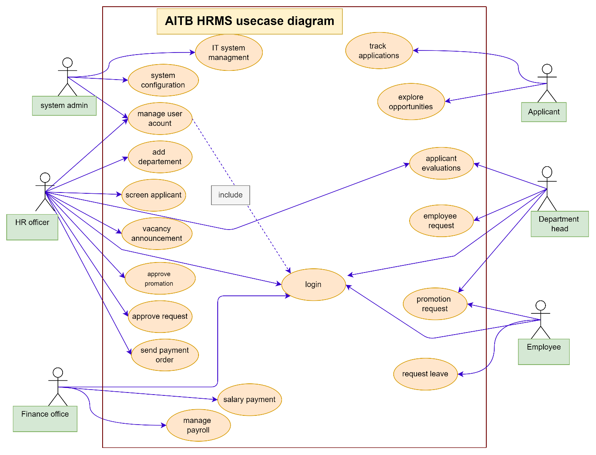
Figure 1: System use case

5.2.1 System use case description
Table 6: Login System use case description
Use case name | Login
System Use case number | SU1
description | Any user who wants to access the system must be Authorized and login to the system.
Actor | Department Head, Employee, Finance Officer HR Officer and System Admin
Pre-condition | The users must be already register (the user must have user name, password and account type)
Basic course of action | - The users browse the system  - The users click login link  - The system displays the login page  - The users enter the identification  - The users click on login button  - The system takes the user to the page.  - The use case end
Alternative course of action | A. If the identification is not correct  A5. The system displays identification wrong  A6. The use case goes to step 4 in the basic course of action  A7. The use case ends
Post condition | The system display user logged in to the system

Manage Account Use Case Description
Table 7: Create user account, delete user account and update user account
Use case name | Create user account
Use Case number | SU2
description | This use case helps the user when it is necessary to create new user account.
Actor | HR officer, System admin
Pre-condition | HR officer login to the system
Basic course of action | 1. the HR officer browse the system  2. HR officer selects create account  3. The system display employee registration form.  4. HR officer fills all information and click create button.  5. click create account  6. The system save the new account  7. The system display message successfully crate the account  8. HR officer Upload information  9. Use case is ends
Alternative Course of action | A. If HR officer enters wrong information  A3. System displays information is wrong message  A4. The use case goes to step 3 in the basic course of action  A5. The use case end
Post condition | A new user account is created

Use case name | Delete user account
Use Case number | SU3
description | HR officer , system admin delete the account if it is not necessary
Actor | HR officer, system admin
Pre-condition | HR officer, system admin login to the system and account must exist
Basic course of action | 1.HR officer , system admin Clicks manage account.  2.Officer, system admin click delete account button,  3. HR officer, system admin fill required information.  4. Click delete account  5. Search found from database.  6. Display searched result.  7. Click confirm delete account button.  8. Delete account form database.  9. Delete account notification.
Alternative Course of action | A. If account does not exist  A3. System displays message account does not found  A4. The use case goes to step 3 in the basic course of action  A5. The use case end
Post condition | user account is deleted

Use case name | Update user account
Use Case number | SU4
description | System admin, HR officer Update the account
Actor | System admin, HR officer
Pre-condition | System admin, HR officer login to the system and account must exist
Basic course of action | 1.System admin, HR officer browse user home page system  2. System admin, HR officer Click update account  3. System admin, HR officer fill required information.  4. Click update account  5. Search found from database.  6. Display searched result.  7. Click update account button.  8. update account form database.  9. update account notification.
Alternative Course of action | A. If account does not exist  A3. System displays message account does not found  A4. The use case goes to step 3 in the basic course of action  A5. The use case end
Post condition | user account is Updated

Table 8: Manage Account System use case description
Use case name | Employee Request
System Use case number | SUC5
Description | This use case enables to submit employee request from department database
Actor | Department Head
Basic function | Department address the problems by filling the employee request form and send to HR officer page
Pre-condition | There is vacant position
Basic Course of Action | - The Department Head browses the home page  - The department login to the system  - The system authenticates the user  - The department selects the request form  - The department fills the request form  - The department send request to HR office database  - The system feedback request is “sent”  - The Department Head exit from the system
Alternate course of action | A. Department Head doesn’t have access privilege to use the system  A2. The system informs the user is invalid  A3. The system tells the user to fill correct information  A4. The use case goes to step 2 in the basic course of action  A5. Use case ends  B. The Department Head not fill request form properly  B4. The system informs to fill all information correctly  B5. The use case goes to step 5 in basic course of action  B6. Use case ends
Post- condition | The request is sent to HR officer

Table 9: Employee Request System use case description
System use case name | Approve request
System Use case number | SUC6
Description | This use case enables to approve the request when there is request letter from the department then HR officer should approve the request form
Actors | HR officer
Basic function | Controlling the information in the database and approve request
Pre-condition | Employment request
Basic Course of Action | - HR officer browse the system  - HR officer login to the system  - The system authenticates the user  - HR officer select the request approval form  - HR officer check the request  - HR officer approve the request  - Approved request is added to department head database  - The system sends message approval is successful  - HR officer exit from the system  10.Use case ends
Alternate course of action | A. HR officer doesn’t have access privilege to use the system  A2. The system informs the invalidity of the input  A3. The use case goes to step 2 in basic course of action  A3. Use case ends  B. HR officer does not approve the request  B5. The system sent “request is not approved”  B6. The use case goes to step 5 of employee request in basic course of action  B6. Use case ends
Post- condition | Request is Approved and recorded in the department database and the “request is approved” message should be display for the user

Table 10: Approve Request System use case description
System use case name | Vacancy Announcement
System Use case number | SUC7
Description | Used to announce the vacant position for the applicants
Actor | HR officer
Basic function | Upload the vacancy file and post to the applicant
Pre-condition | Approved Request
Basic Course of Action | - The HR officer browses the home page  - HR officer login to the system by inserting the user name and password  - The system authenticates user information  - The HR officer selects the vacancy announcement  - The HR officer fill all information  - The HR officer posts the filled vacancy announcement  - The use case ends
Alternate course of action | A. If the HR officer doesn’t have access privilege to use the system  A2. The system informs the user to fill the correct information  A3. The system invalidates the user inputs  A4. The use case goes to step 2 in basic course of action  A5. Then use case ends  B. If the vacancy information is not uploaded  B5. The system informs the HR officer to fill correct information  B6. The use case goes to step 6 in basic course of action  B7. Use case ends
Post- condition: | The vacancy is announced

Table 11: Vacancy Announcement System use case description
System use case name | Applicant Registration
System use case number | SUC8
Description | These use case used to register applicants
Actor | Applicant
Basic function | - The basic function of these actor is to register based on the schedule
Pre-condition | Vacancy announcement
Basic Course of Action | - The Applicant browses the home page  - The applicant clicks on register icon  - The applicant inserts vacancy id from posted vacancy  - The applicant fills the form  - The applicant clicks submit button  - The applicant submits the filled information to HR office DB  - The system responds the registration ID (code) to the registering applicant.  - The use case ends.
Alternate course of action | A. If the applicant does not fill the form correctly  A3.the system informs the applicant to fill correct input  A4. Use case goes to step 5 in basic course of action  A5. The use case ends
Post- condition | HR officer fill applicant registration form and the database system should record the registered applicant.

Table 12: Applicant registration System Use Case description
System use case name | Applicant Evaluation
System use case number | SUC9
Description | Used to evaluate the registered applicant based on different criteria
Actor(s) | Department Head, HR Officer
Basic function | - The basic function of these actor is to evaluate the registered applicant
Pre-condition | Applicant Registration
Basic Course of Action | 1. The Department Head login in to the system  2. The system validates the inputs  3. The Department Head selects evaluation form  4. The Department Head records the result and send to HR office  5. The use case ends.
Alternate course of action | A. Department Head doesn’t have access privilege to use the system  A2. The system informs the user is invalid  A3. The system tells the user to fill correct information  A4. The use case goes to step 2 in the basic course of action  A5. Use case ends  B. The Department Head not fill evaluation form properly  B4. The system informs to fill all information correctly  B5. The use case goes to step 4 in basic course of action  B6. Use case ends
Post- condition | The Department Head evaluates the applicant and HR Officer view evaluated applicant

Table 13: Applicant Evaluation System Use Case description
System use case name | Screen Applicant
System use case number | SUC10
Description | HR officer screen evaluated applicants
Actor | HR officer
Basic function | The basic function of these actor is to screen the evaluated applicants
Pre-condition | Evaluated applicant
Basic Course of Action | 1. HR officer browses the home page  2. The HR officer login to the system  3. The system validate the login inputs  4. The HR officer check the evaluation  5. The HR officer select applicant screening form  6. The screened value are sent to the applicant database  7. The system send message the applicant is screened  8. Use case ends
Alternate course of action | A. If the HR officer does not have access privilege to the system  A2. The system informs the user to input correctly  A3. The use case goes to step 2 in the basic course of action  A4. The use case ends
Post- condition | HR officer screen the past applicant and the database will record the screened applicant.

Table 14: Screen Applicant System Use Case description
System use case name | Placement
System use case number | SUC11
Description | If applicants screened, HR Officer place competent applicants as AITB employee
Actor | HR officer
Basic function | The basic function of these actors is to place applicants based on their profession, qualification etc.
Pre-condition | Screened Applicant
Basic Course of Action | 1.The HR officer login to the system having user name and password  2. The system authenticates the user inputs  3. The HR officer select placement form and add applicant details  4. The system informs the HR officer “placed successfully” and employee information is recorded in the database  5. The use case ends
Alternate course of action | A. If the HR officer input is not correct  A2. The system informs the HR officer to input correct information  A3. The use case goes to step 2 in the basic course of action  A4. Use case ends
Post- condition | HR officer fill placement form and the database system should record the placed applicant.

Table 15: Placement system use case description
System use case name | promotion Request
System use case number | SUC12
Description | This use case enables the employee to submit the request for getting self-promotion
Actor | Employee, Department Head
Basic function | Employee request the department Head for promotion  Department Head accept the request and send to HR office  Department recommend the request and send to HR office
Pre- condition | Employee request for promotion
Basic Course of Action | 1. Employee browse the home page  2.The employee login to the system to request the department Head for promotion  3. The system validates the user inputs  4. The employee selects the promotion request form  5. The employee fill the form correctly  6. The employee submits his/ her request to the department  7.The system informs the employee request is submitted successfully  8. The use case ends
Alternate course of action | A. If the employee does not have privilege to access to the system  A2. The system informs the employee to input data correctly  A3. The use case goes to step 2 in the basic course of action  A4. The use case ends  B. The department Head not select the recommend option  B1. The use case goes to step 5 in the basic course of action  B3. Use case ends
Post- condition | The employee submits the request for promotion

Table 16: Promotion Request system use case description
System use case name | Approve Promotion
System use case number | SUC13
Description | This use case enables to approve the promotion request
Actor | HR officer
Basic function | HR officer approve the requested promotion
Pre-condition | Department recommend promotion request
Basic Course of Action | 1. The HR officer login to the system  2. The system validates the user inputs  3. The HR officer selects the promotion request approval form  4. The HR officer checks the employee details from the database  5. The HR officer verifies the requests  6. The HR officer respond the approval as per user information  7. The use case ends
Alternate course of action | A. If the HR officer does not have privilege to access to the system  A2. The system informs the user to input data correctly  A3. The use case goes to step 2 in the basic course of action  A4. The use case ends
Post- condition | The promotion request is approved

Table 17: Promotion Approval system use case description
System use case name | Send Payment order
System use case number | SUC14
Description | Used to send salary payment order to finance office
Actor | HR officer, Finance officer
Basic function | HR officer Send salary payment order  Then Finance officer receives the payment order
Pre-condition | The HR officer send salary payment order messages(form)
Basic Course of Action | - The HR officer login to the system  - The system authenticates the users input  - The HR officer select the payment form  - The HR officer fill the form  - HR officer sends the payment order to finance office  - The system informs the HR officer salary payment order is sent  - Use case ends
Alternate course of action | A. The system invalids the user input  A2. The system informs the HR officer to input correct information  A3. The use case goes to step 2 in the basic course of action  A4. Use case ends  B3. The salary payment order is not sent  B4. The use case goes to step 3 in the basic course of action  B5. The use case ends.
Post- condition | HR officer send salary payment order

Table 18: Send Payment order system use case description
System use case name | Salary Payment
System use case number | SUC15
Description | This use case describes salary payment for employees
Actor | Finance officer, employee
Basic function | Employee gets salary
Pre-condition | The HR officer send salary payment order messages(form)
Basic Course of Action | 1. the Finance officer browse the home page  2. The Finance officer login to the system  3. The system authenticates the users input  4. Finance officer select the payroll form  5. The filled information is saved in data base  6. The finance officer print the form.  7. Use case ends
Alternate course of action | A. The system invalids the user input  A3. The system informs the user to input correct information  A4. The use case goes to step 2 in the basic course of action  A5. Use case ends  B3. The finance officer not information correctly  B4. The use case goes to step 5 in the basic course of action  B5. The use case ends.
Post- condition | Pay salary for the employee

5.2.2 Sequence Diagram
Sequence diagrams are used to depict graphically how objects interact with each other via messages in the execution of a use case or operation. They illustrate how the messages are sent and received between objects and in what sequence.
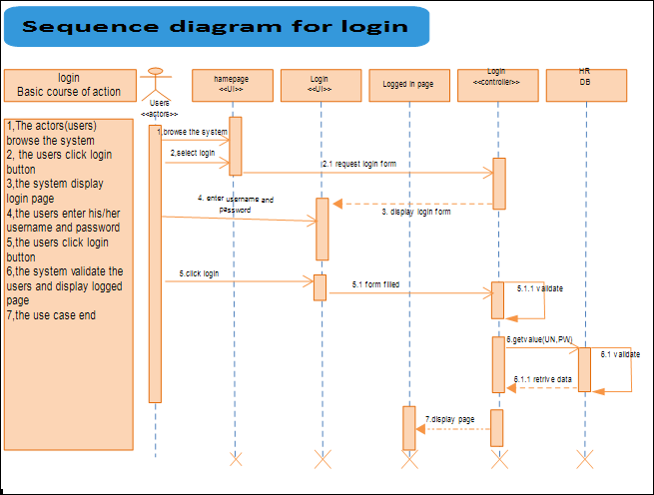
Figure 2: Login sequence diagram

Manage Account
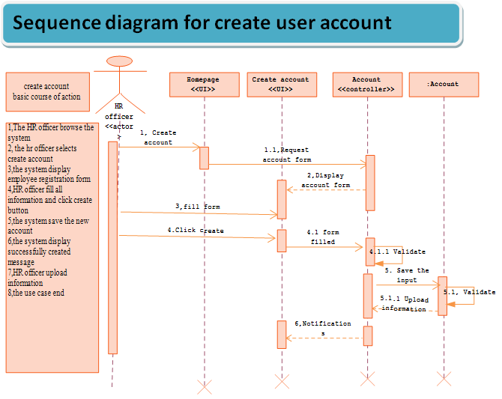
Figure 3: Sequence for Create account
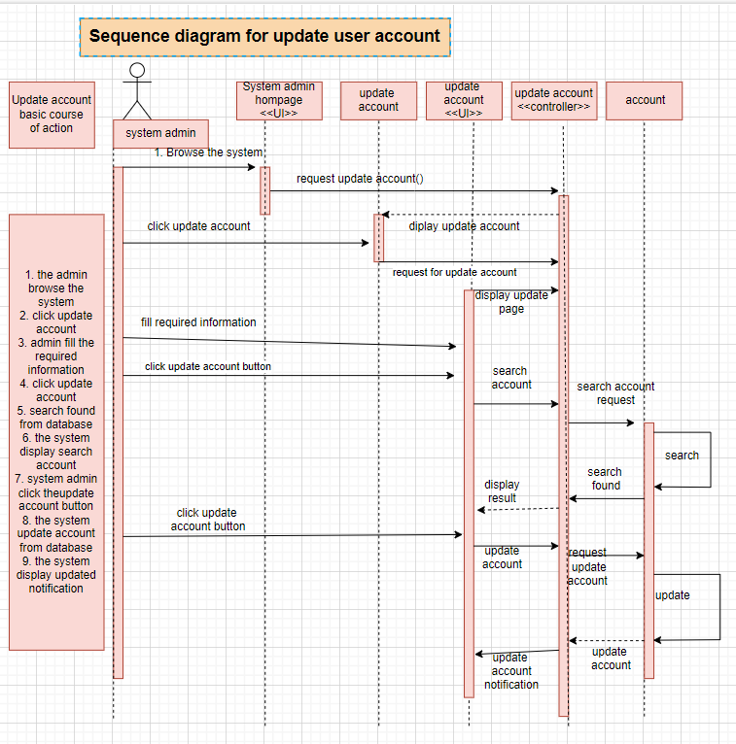

Figure 4: Sequence diagram to Update account
Figure 5: sequence diagram for Delete user account
Figure 6: Sequence diagram for employment requesting

Figure 7: Sequence diagram for Promotion Request
Figure 8: Sequence diagram for approve request
Figure9: sequence diagram for Vacancy Announcement
Figure 10: Sequence diagram for Applicant Registration
Figure 11: sequence diagram for Applicant evaluation
Figure 12: screen applicant sequence diagram
Figure 13: sequence for send payment order
Figure 14: sequence for employee salary payment

5.2.3 Activity diagram
Activity Diagrams are used to Document the logic of a single operation /methods, a single use case, or the flow of logic of a business operation. In many ways, Activity Diagrams are the object_ oriented Equivalent of flow charts and Data-flow Diagrams (DFD) from structure development. We identified some activity diagrams to clearly show the activities in the system.
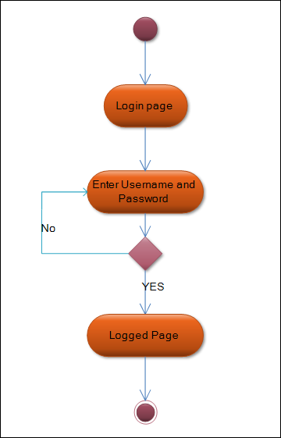
Figure 15: Activity diagram for Login

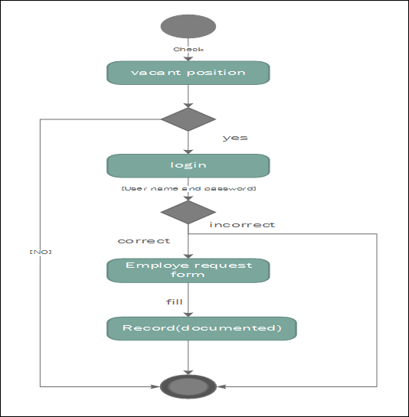
Figure 16: Activity diagram for Vacancy announcement
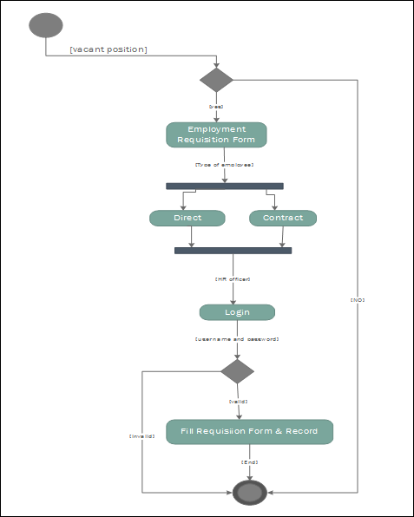
Figure 17: Activity diagram for Employee Request
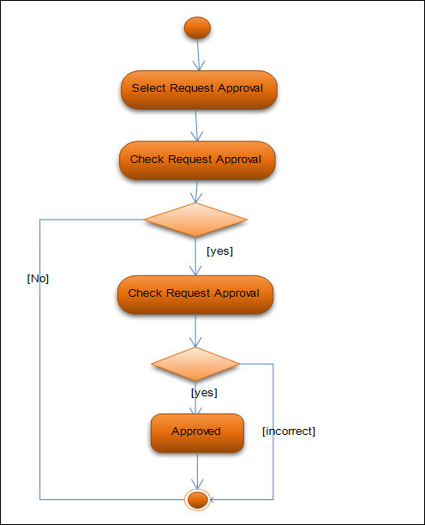
Figure 18: Activity diagram for Approve Request
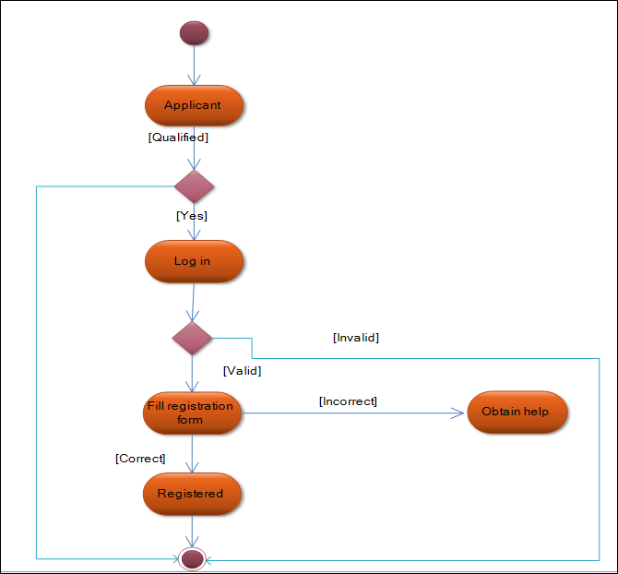

Figure 19: Activity diagram for Applicant Registration
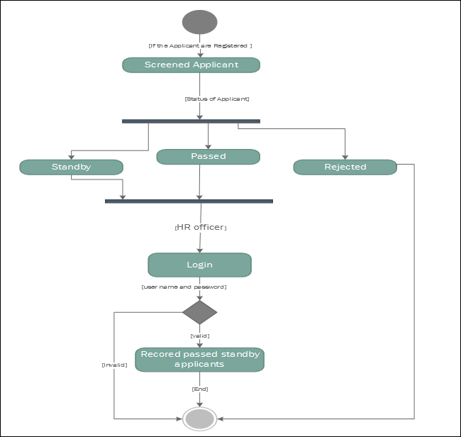
Figure 20: Activity diagram for Screen Applicant
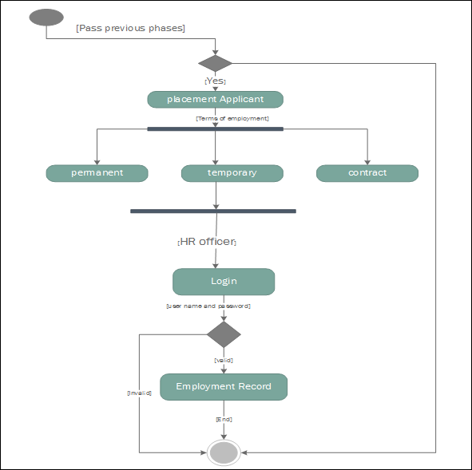
Figure 21: Activity diagram for Employee Placement

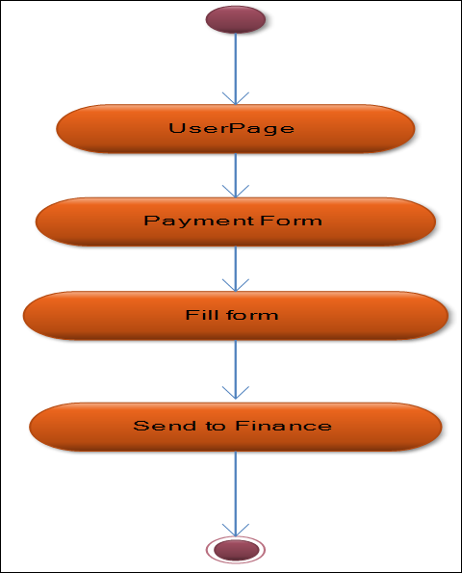

Figure 22: Activity diagram for Send Payment Order
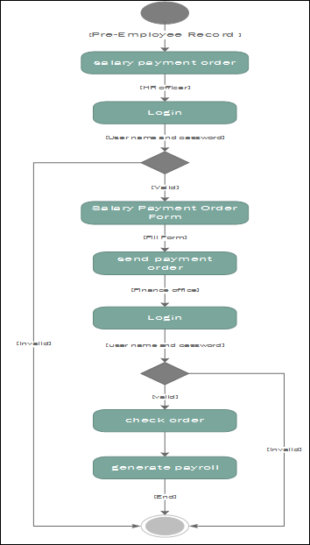
Figure 23: Activity diagram for salary payment
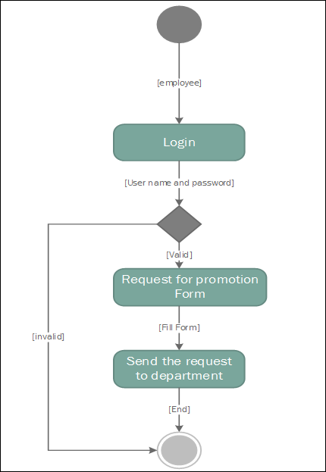
Figure 24: Activity diagram for Promotion Request

5.2.4 Conceptual modeling: Class diagram
Class diagrams identify the class structure of a system, including the properties and methods of each class. Also depicted are the various relationships that can exist between classes, such as an inheritance relationship. The class diagram is one of the most widely used diagrams from the UML specification. These tools can synchronize models and code, reducing workload, and can also generate class diagrams from object-oriented code, for "code-then-design" maintenance projects. The purpose of design is to model how the software will be built. Thus, the purpose of design-class modeling is to model the static structure of how the system is going to be built.

Figure 25: Conceptual modeling Diagram

5.2.5 User Interface Prototyping
To our users, the user interface is the system. This may help to gather more requirements from users or show how the system works. If we build an ineffective user-interface (UI) to the system then it really does not matter how good the rest of the system is: users are going to hate what we have built for them. So, we, the, developers understand, and then apply, at least the fundamentals of UI development.

5.2.5.1 User Interface flow diagram
A diagram that depicts major UI elements and how users transition between them; used to explore the high-level usability of a system or to overview or document the user interface of a system.
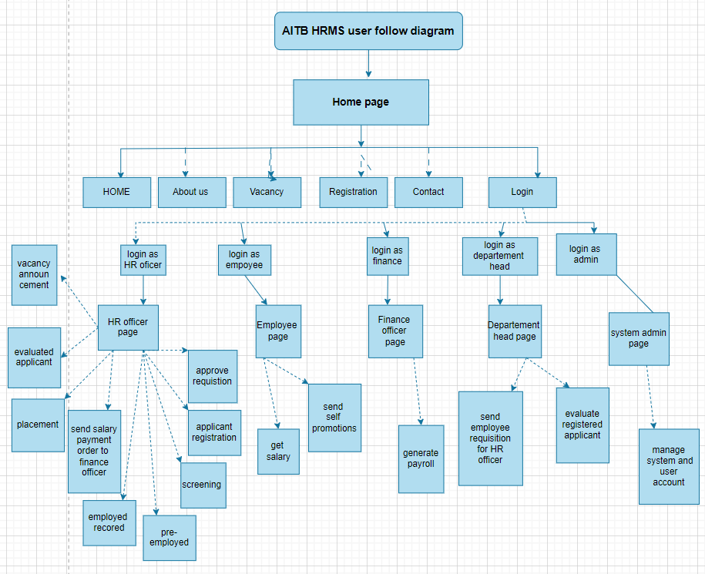
Figure 26: User Interface flow diagram

CHAPTER SIX

6. System design

6.1 Introduction
System design has a great part which describes the first solution of the system problem. So designing a system is the important and necessary step in any computer system. System design provides a clear description of the overall design of the AITB HRMS and bridging the gap between desired and existing system in a manageable way.
The internal part of this system design document is organized as: class type architecture, class modeling, class diagram, component diagram, State chart modeling, User Interface design.

Class type architecture
Table 19: Class type architecture
Layer | Description
Interface | This layer wraps access to the logic of our system. There are two categories of interface class – user interface (UI) classes that provide people access to our system and system interface (SI) classes that provide access to external systems to our system. In our system there is one main home page interface that enables people enter (login) to the system and large number of user inter faces to work (communicate) each other and with other layers. Some UI like homepage, login, registration interface
Process | The process or controller layer implements business logic that involves collaborating with several domain classes or even other process classes.  In this layer our system has one domain that implements the logic of our system. Login control what interface user must get based on account.
Domain | This layer implements the concepts relevant to our business domain focuses on the data aspects of the business objects plus Behaviors specific to individual objects. And implements the concept related to the business domain focusing on the data aspects of the business.  In this layer our system has n such domain classes that are concerned with data are the following.  - Employee Detail information  - Employee account
Persistence | Persistence layers encapsulate the capability to store, retrieve, and delete objects/data permanently without revealing details of the underlying storage technology in the system. Often implement between object schema and database schema and there are various available to us.
System | System classes provide operating-system-specific functionality for our applications, isolating our software from the operating system by wrapping OS-specific features, increasing the portability of your application.

Process
(Controller)
User interface
Persistence
(Data)
Domain
(Business)
Data base
System
(Infrastructure, platform)

Figure 27: class type architecture

6.3 Class modeling
Class models shows the classes of the system, their Interrelationship (including inheritance, aggregation, and association), and the operations and attributes of the classes.
Figure 28: class modeling

6.4 State chart modeling
State chart diagram is used for modeling the dynamic aspects of systems. It is similar to activity diagram. Both activity and state chart diagrams are useful in modeling the lifetime of an object. However, activity diagram shows flow of control from activity to activity; whereas state chart diagram shows flow of control from state to state. State chart modeling is a dynamic modeling technique, one that focuses on identifying the behavior within our system, behavior specified to the instances of a single class. It tries to show different state that an object passes through its life span. However, it is not necessary to build state chart for every class in the system; only state charts of complex objects are necessary to be modeled. State chart diagram enables us to observe the state of complex that simplifies implementation.
Figure 29: state chart diagrams for new employee register
Figure 30: State chart diagram for Login

6.5 Collaboration modeling

A collaboration diagram describes interactions among objects in terms of sequenced messages. Collaboration diagrams represent a combination of information taken from class, sequence, and use case diagrams describing both the static structure and dynamic behavior of a system.
- The rectangle represent the various objects involves that make up the application,
- The line between the classes represents the relationships (association, aggregation, composition, dependencies, or inheritance)
Figure 31: collaboration model for login
Figure 32: collaboration model for employee register

6.6 Component modeling
A component diagram describes the organization of the physical components in a system. Components are modeled as rectangles with two smaller rectangles jutting out from the left hand side. Components have dependencies on the interface of other components.
Figure 33: component modeling diagram

Chapter SEVEN

7. Implementation and Testing

7.1 Introduction
In this chapter we mainly focus on the implementation part, implementation concerned with the type of material (Hardware and software required), techniques to develop the system, algorithm for the system, code samples of the system, data preparation, how to install the system, some testing techniques, startup strategy for the new installed system are briefly described in this part of documentation.

7.2 implementation

7.2.1 System implementation

Implementation Environment
This section tells the reader exactly what tools and hardware were used to build and run the system.
- Hardware Requirements: Specify the development machine (e.g., Processor, RAM) and the server requirements.
- Software Requirements: List the versions of Node.js, MongoDB, and React. Mention the IDE used (like VS Code) and testing tools (like Postman).
System Architecture Implementation
The architecture of the Web-Based Human Resource Management System (HRMS) follows a Three-Tier Architectural Pattern, which separates the application into three logical and physical computing tiers: the Presentation Tier, the Logic Tier, and the Data Tier. This separation ensures scalability, ease of maintenance, and enhanced security for the Amhara Innovation and Technology Bureau.
- Presentation Tier (Client Side): Developed using React.js, this layer handles the user interface and user experience. It captures inputs from the five actors (HR, Dept. Head, Finance, Employee, and Applicant) and displays data fetched from the server.
- Logic Tier (Server Side): Developed using Node.js and Express.js, this layer acts as the brain of the system. It processes business logic, validates user credentials, and manages the communication between the frontend and the database.
- Data Tier (Database): Developed using MongoDB, this layer stores all persistent data, including employee records, leave history, and payroll details, in a flexible NoSQL document format.
Component Interaction (MERN Stack)
The interaction between components is managed through a Restful API (Representational State Transfer).
- Request Phase: When a user (e.g., an Employee) submits a leave request, the React front-end sends an HTTP POST request containing JSON data to the Express.js back-end.
- Processing Phase: The Node.js server receives the request, verifies the user's JWT (JSON Web Token) for authorization, and applies business rules (e.g., checking if the employee has enough leave balance).
- Data Phase: The server interacts with the MongoDB database using the Mongoose ODM to save the request.
- Response Phase: Once the database operation is successful, the server sends an HTTP status code (e.g., 201 Created) back to the client, which then updates the UI to show a "Success" message.
Implementation by Actor (Module Documentation)
Break down the implementation based on your five actors. For each, describe the Core Logic:
- HR Officer: Implementation of the employee CRUD (Create, Read, Update, Delete) and vacancy posting logic.
- Department Head: The logic for approving/rejecting leave and performance reviews.
- Finance Officer: The implementation of payroll calculation algorithms.
- Employee: Self-service features like profile updates and leave applications.
- Applicant: The registration and file upload (Resume/CV) handling
Security Architecture
To protect sensitive HR and Finance data, a multi-layered security architecture is implemented:
- Authentication Layer: Uses JSON Web Tokens (JWT). Upon successful login, the server issues a token that the client stores and sends in the header of every subsequent request.
- Authorization Layer (RBAC): Role-Based Access Control is enforced at the server level. Specific API endpoints are protected by middleware that checks if the user's role (extracted from the JWT) has permission to perform the action (e.g., only Finance can access /api/payroll).
- Data Encryption: Passwords are never stored in plain text; they are hashed using the Bcrypt algorithm before being saved to MongoDB.
Deployment Architecture
The system is designed to be deployed in a Client-Server Environment.
- Server Hosting: The Node.js API and the React build files are hosted on a web server (e.g., Nginx or PM2).
- Database Hosting: The MongoDB database can be hosted locally within the Bureau’s intranet for maximum security or on MongoDB Atlas for high availability and cloud backups.
- Client Access: Users access the system through standard web browsers (Chrome, Firefox, Edge) via a dedicated URL or IP address within the local network.

7.3. System User Interface (Screenshots & Descriptions)

7.3.1 AITB Public Portal: The Institutional Home Page
The Home Page serves as the digital front door for the Amhara Innovation and Technology Bureau. It is designed to bridge the gap between complex government operations and public accessibility, focusing on high-speed navigation and clear information hierarchy.
- Feature Set: The page utilizes a Responsive Hero Section with a high-definition background image representing Ethiopia’s digital transformation. Below the fold, a Grid System categorizes the Bureau’s primary sectors: Digital Literacy, Startup Support, and E-Government Services.
- Dynamic Content: It integrates an Announcement Ticker or "Latest News" feed that pulls data from the Node.js backend, ensuring that stakeholders are kept up-to-date with the Bureau's latest initiatives and regional tech policies.
- User Action: Citizens and visitors can browse available services, download official digital policy documents, or use the "Quick Links" section to jump directly to the Secure Login Gateway for specialized departmental tasks
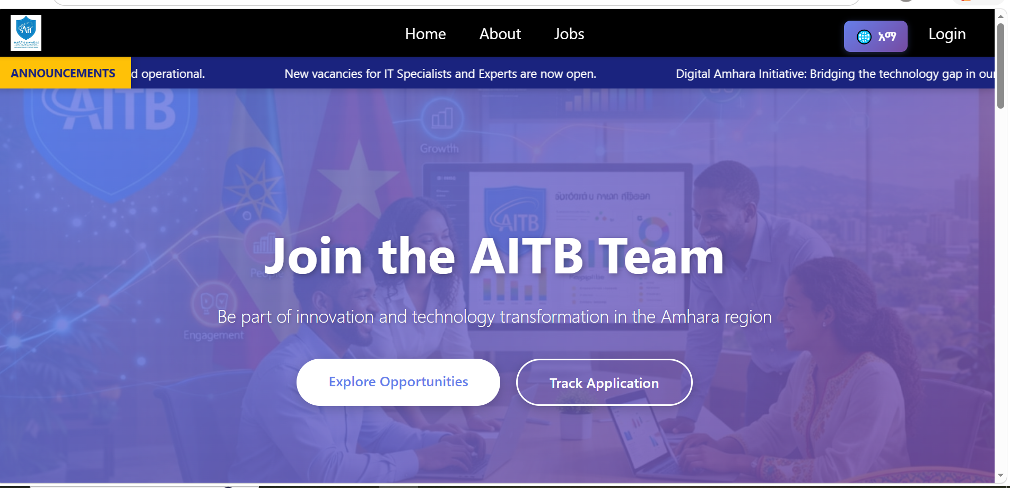 Figure 35: public home page

7.3.2. User Authentication and Gateway
The login interface is the primary security layer of the system. It is designed with a minimalist aesthetic to ensure ease of use while maintaining institutional branding for the Amhara Innovation and Technology Bureau.
- This interface handles multi-user authentication. It utilizes React-Hook-Form for client-side validation and interacts with the Node.js backend to issue a JSON Web Token (JWT) upon successful login.
- User Action: Users enter their unique credentials; the system then decodes their assigned role (e.g., HR_OFFICER) and redirects them to the appropriate dashboard.
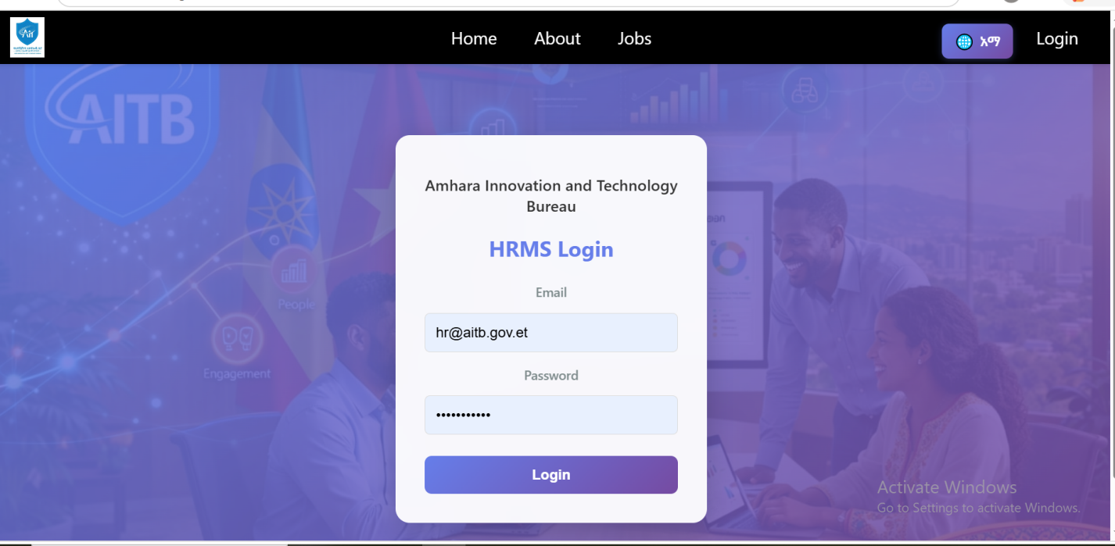
Figure 35: login page

7.3.3. HR Officer: Centralized Personnel Dashboard
This is the "Command Center" for the HR department. It provides a real-time summary of the organization's human capital.
- The dashboard uses data visualization (via Chart.js or Recharts) to show staff distribution across departments. It features a sidebar navigation menu that allows the HR Officer to manage the entire employee lifecycle.
- User Action: The HR Officer can monitor pending leave requests, view total active staff, and access the "Add New Employee" modal to perform CRUD operations.
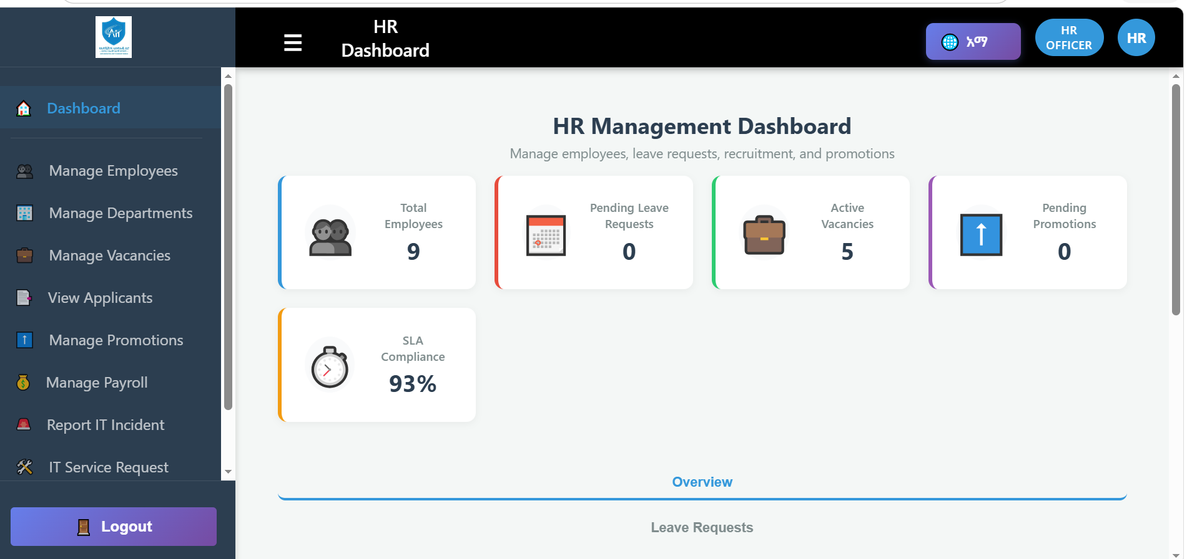
Figure 35: HR officer page

7.3.4. Department Head: Workflow Approval Interface
This interface focuses on managerial tasks, specifically filtering out administrative noise and focusing on decision-making.
- This module displays a filtered list of data from the MongoDB Leave and Appraisal collections that belong specifically to the Head's department.
- User Action: The Department Head can review employee performance scores and "Approve" or "Reject" leave requests. These actions trigger an automatic status update in the database and notify the employee.
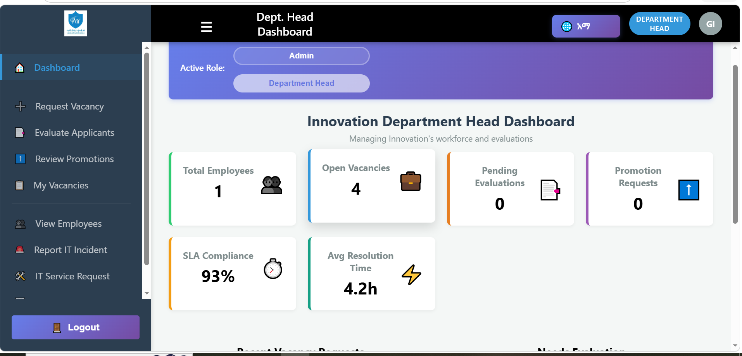
Figure 35: Department head page

7.3.5. Employee Self-Service (ESS) Portal
The ESS portal empowers employees to manage their own data, reducing the administrative burden on the HR department.
- This interface allows employees to view their personal profile, digital ID information, and appraisal history. It features a "Leave Balance" card that dynamically calculates remaining days using backend logic.
- User Action: Employees can submit new leave requests and track the progress of their applications (Pending/Approved/Rejected) in real-time.
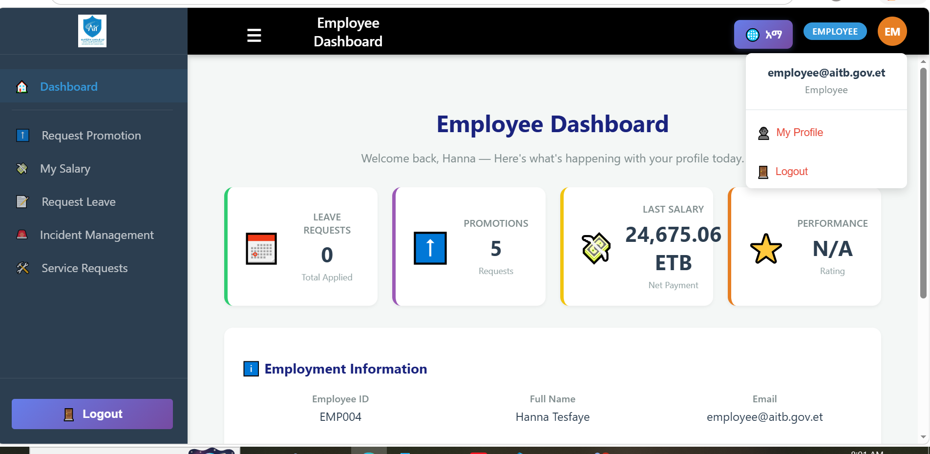
Figure 35: employee page

7.3.6. Public Recruitment (Applicant) Portal
This is the only public-facing part of the system, designed to attract and register external talent.
- This page displays active job vacancies stored in the JobPost collection. It includes a responsive registration form for new applicants.
- User Action: External applicants can browse open positions, fill out their professional details, and upload their resumes (as PDF files), which are then stored in the system's file storage (e.g., Cloudinary or local server storage).
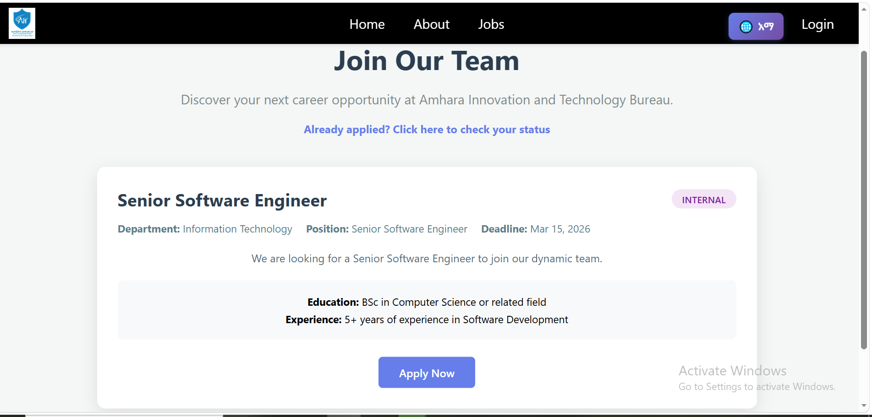
Figure 35: Public Recruitment (Applicant) Portal page

7.4 Test Procedures
- Unit testing: Verification (A set of operations that the software correctly implemented a particular function) on the smallest element of the program i.e. the modules are tested alone in order to discover any error in the code.
- Some of errors that controls
When the field is empty, the system will display username required.
When we enter a character instead of numeric value, the system will display emp id should be number.
When we enter a numeric value instead of character, the system will display user name should be character.
- Integrated testing: The process of bringing together all the modules that a program comprises for testing purpose. This verified that the React frontend correctly communicates with the Node.js API. We ensured that when a user clicks "Submit" on a leave request, the data is successfully sent to the Express route and saved in MongoDB.

Chapter EIGHT

8. Conclusions and Recommendation

8.1Conclusion
The development of the Web-Based Human Resource Management System (HRMS) for the Amhara Innovation and Technology Bureau (AITB) marks a significant transition from traditional, paper-burdened administration to a modern, data-driven environment. By moving away from manual record-keeping, the Bureau has addressed critical vulnerabilities such as data redundancy, information loss, and administrative stagnation..
Since the success and failure of any system depends on gathering the right information through different fact-finding techniques and user involvements, the team has made the best effort to gather requirements. After a detail review and study of the existing system of HRM models have been designed to reflect the new system that is supposed to solve problems.
Designing computerized HRM of AITB helps to maintain a computer based HRM.
In order to solve different problems existed the team has tried to propose a solution that at least reduce the existed problems and model the proposed system using different tools and methodologies. We believe that different tools and techniques has helped us a lot in capturing real user requirements and model the right system for the users for their day to day transactions. Thus it should have the precedence in know-how and experience in collecting, processing and utilizing information.

8.2 Recommendations
As its obvious the use of and advantage of computerized systems over manual information systems, we strongly recommend AITB HRM to implement our new system in order to achieve capabilities like reliable data keeping, fast data processing and transmissions, well defined communications among departments, sharing a single database and so on.
It’s true that our country’s is yet developing country that most things are done manually which in turn is affecting our economy, and new systems like our systems should be adopted so that it highly reduces the burden of the campus. And make the service recipient happy. Which clearly notify the saying “simplicity is the ultimate sophistication?”

Reference
[1]. (2006). human resource management. kombolcha: human resource.
[2]. (2006, january). google. Retrieved from oservation: https://www.goodle.com
[3]. (2006, january 1). google. Retrieved january 1, 2006, from www: www.yourdictionary.com › Dictionary Definitions › observation
[4]. (2000, september 2). interview. Retrieved september 2, 2000, from interview: www.dictionary.com/browse/interview
[5]. (2012, june 1). questionaerie. Retrieved 01 01, 2012, from observation: www.merriam-webster.com/dictionary/questionnaire
[6]. Amhara Innovation and Technology Bureau. Annual Report 2024. Bahir Dar, Ethiopia.

